ID 2209 - Distributed Artificial Intelligence and Intelligent Agents

Assignment 1 - GAMA and Agents

Group 3

Albert Asratyan

Justas Dautaras

08.11.2019

In this assignment, we were tasked with creating a festival simulation in GAMA, and implement the functionalities that emulate real world people in festivals where a person can get thirsty or hungry. These states initiate a condition that makes them go to an information stand which has the location of either a food court or a water stand. Then the person goes to that location, refills its status and continues dancing in a random location.

**How to run**

Run GAMA 1.8 and open Main.gaml file. Press the green button ‘my_experiment’ to run the simulation.

**Species**

**Agent People**

This agent has the following behaviour patterns: beIdle (when not hungry or thirsty, the agent just wanders around), moveToTarget (the agent moves to a set target, be it an info stand or a food/water stand), and enterStore (the agent enters the info stand or food/water stand and performs a corresponding action). Has two integer variables, is_hungry and is_thirsty, which decrease every cycle and are refreshed only when the agent replenishes the hunger/thirst at the corresponding stand.

**Agent Info Stand**

This agent is responsible for providing coordinates of food/water stands to the people agent. This agent keeps track of all of the food/water stands. When a people agent requests data, the Info Stand agent chooses a random stand of the correct type. Has the following variables: list of points for water stands, list of points for food stands, a random point for a water stand chosen from the list of water stands, a random point for a food stand chosen from the list of food stands.

**Agent Food/Water Stand**

This agent is responsible for refreshing the thirst/hunger counter of the people agent.

**Implementation**

We began this task by watching a tutorial on youtube and then continued with other tutorials and documentation from their site. First of all, we created the necessary species - people, information stand, water stand and food court. Then we assigned attributed to them, such as location, hunger, thirst. And finally, we developed the logic so that hunger and thirst would decrease and then the agents would find their ways to fill it up again.

**Results**

To demonstrate that we successfully accomplished the task we made the agents change colors. When an agent is thirsty, its color becomes blue. If hungry - blue and if both its black. Similarly the water stand is blue and the food court is red. So we can see if the agent is going to the corresponding location.

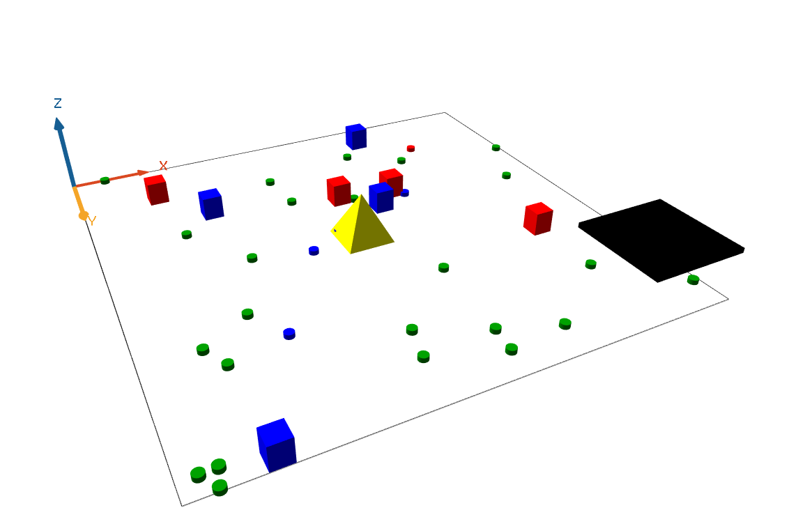

*Figure 1: A screenshot of the final solution + creative part.*

**Challenge 1**

To complete the first challenge we had to implement a short term memory for agents as well as sharing of their knowledge. The way this works is in the following way:

* The person asks information stand for the location of either food or water.
* The information is then memorized with a chance of forgetting it 0.02% each cycle.
* When a person is near another person (distance 5), a person with no knowledge asks another person if he knows where a water or food stand is.
* If a person knows the inquired information, It shares with it.

**Challenge 2**

To complete the second challenge we added a new agent called ‘guard’ which would take care of the people agents that had a random ‘bad’ attribute (bad guest at the festival). It is done in this order:

* A ‘not bad’ person detects other bad person within a 5 range radius.
* The person goes to the information stand.
* Information stand reports the location of the guard.
* Person goes to the guard and escorts him to the bad person.
* Guard kills the bad person and return to his original location whilst the person returns to his previous location.

*The ‘bad’ attribute can occur to any idle person with a probability of 0.1% per cycle. Once a person is ‘bad’ he stays at his location and wonders.

**Creative implementation**

For our creative solutions, we added a new object ‘tent’ and a global attribute ‘rain’. Rain is a boolean attribute which is controlled within the running experiment and allows to control whether it is raining at the festival or not. If it is raining people go run to hide below a tent and once it stops raining people go back to either the places they were last in or if hungry or thirsty - straight to the information stand.

We argue that we should receive a bonus point for creativity in this assignment because not only did we include functionality other than what was asked in the assignment (3d gui, dynamic user controlled global elements), but it is also an interesting visually presentable feature.

|  |  |
| --- | --- |
| *Qualitative/Quantitative questions* | *Answer* |
| Time spent on finding and developing the creative part | 2 hours |
| In what area is your idea mostly related to... | 3D GUI, Dynamic user controlled global elements |
| On the scale of 1-5, how much did the extra feature add to the assignment? | 4 |
| On the scale of 1-5, how much did you learn from implementing your feature? | 5 |

**Discussion / Conclusion**

One of the choices that we had to make is to decide on which of the agents (people or the food/water stand) should be the one asking the other one. We have decided to proceed with the people agent asking, leaving the stands without any real behaviour patterns. All in all, the assignment has taught us how basic agent interaction works in GAMA and is a solid foundation for whatever challenge comes next.